

Sistemas de Control

Tutorial

Installing control toolbox for **python 2.7**

Install Python (2.7) <https://www.python.org/>

Download the last release and install it. For windows users… <https://www.python.org/downloads/windows/>   
  
Python will be probably installed in “C:\Python27\”, to make it easy to use I strongly recommend you to add Python to your environment variables as explained in

<https://stackoverflow.com/questions/3701646/how-to-add-to-the-pythonpath-in-windows-7>

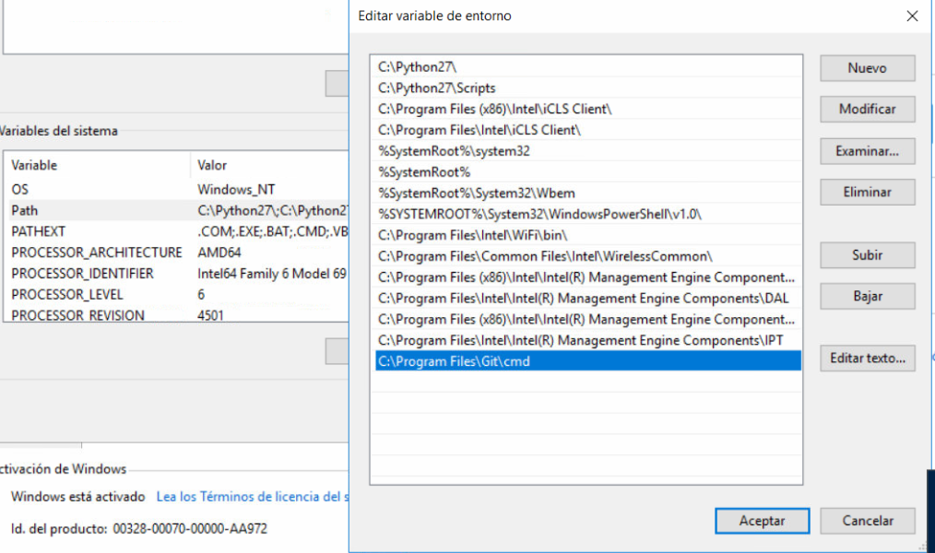

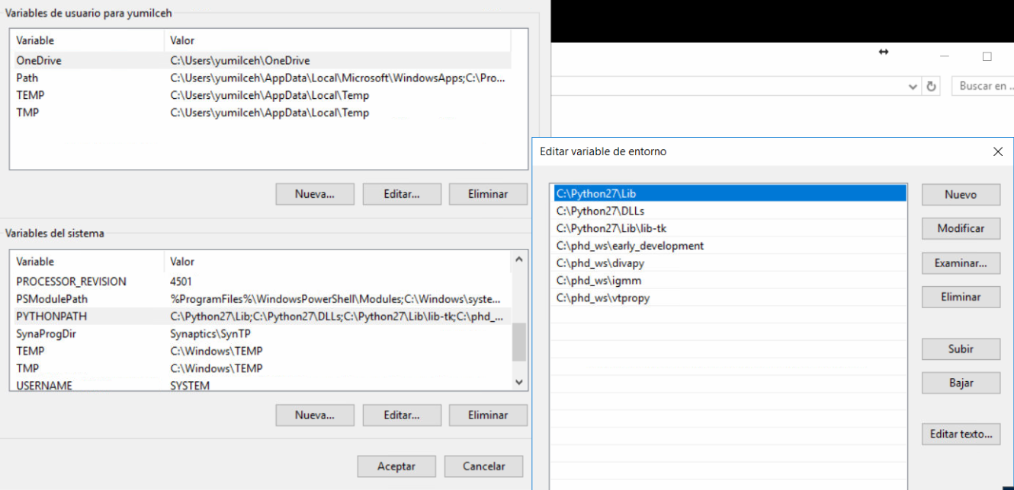

Then open CMD (System symbol) and execute the command “python”... you shouldn’t see any error

Install “pip” <https://pypi.python.org/pypi/pip>

Download get-pip.py from <https://pip.pypa.io/en/stable/installing/>

Then in CMD execute “python get-pip.py” where you saved it. If you get any error try again executing CMD with administrator privileges.

Once you installed pip, open a new command line and execute “pip”. You should get something like:

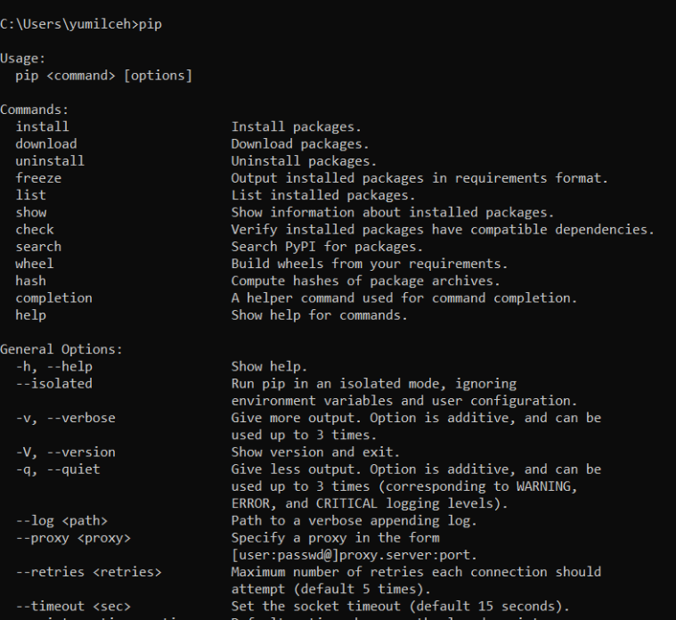”

If it does not work execute again “pip” (Python (or Windows) mysteries).

Install “Ipython” and “Jupyter” <http://jupyter.org/install>

Just do:

python -m pip install --upgrade pip

python -m pip install jupyter

To test your installation open a CMD and try “jupyter notebook”. Your browser will be open with the jupyter interface. Otherwise, something is not properly installed.

Finally, our library. Install “Python-control’ .

When using windows it is better to use pre-compiled packages. They are available in.

<https://www.lfd.uci.edu/~gohlke/pythonlibs/>

First lets install the requirements (download from the link above):

numpy, look for:

* numpy‑1.13.3+mkl‑cp27‑cp27m‑win32.whl
* numpy‑1.13.3+mkl‑cp27‑cp27m‑win_amd64.whl

then in CMD hit: pip install FILE

scipy, look for:

* scipy‑1.0.0‑cp27‑cp27m‑win32.whl
* scipy‑1.0.0‑cp27‑cp27m‑win_amd64.whl

and use pip to install.

install python control and slycot

<https://sourceforge.net/p/python-control/wiki/Home/>

pip install control

in linux you need to intall gfortran liblapack-dev liblapack3 libopenblas-base and libopenblas-dev

pip install slycot (if it does not work look for the respective wheel)

en algunos casos hará falta instalar tkinter:  
apt install python-tk

Control toolbox documentation available on <http://python-control.readthedocs.io/en/latest/intro.html>

Numpy tutorial: https://docs.scipy.org/doc/numpy-1.15.1/user/quickstart.html

Matplotlib tutorial: https://matplotlib.org/users/pyplot_tutorial.html

Máquina_virual

User: lasalle

Password: lasalle